PASSAGE PLANNING FORM
From: | To: |  | Passage Planned By:
Date(s) of Passage: | Date of Planning: |  | Passage Planned By:
No. of Crew On Board: | Expected No. of Guests On Board: |  | Maximum Draft: 3.9m
Distance, berth to berth: |  | ETA at destination:
Estimated Duration Underway: |  | Estimated fuel consumption:

ROUTE OVERVIEW

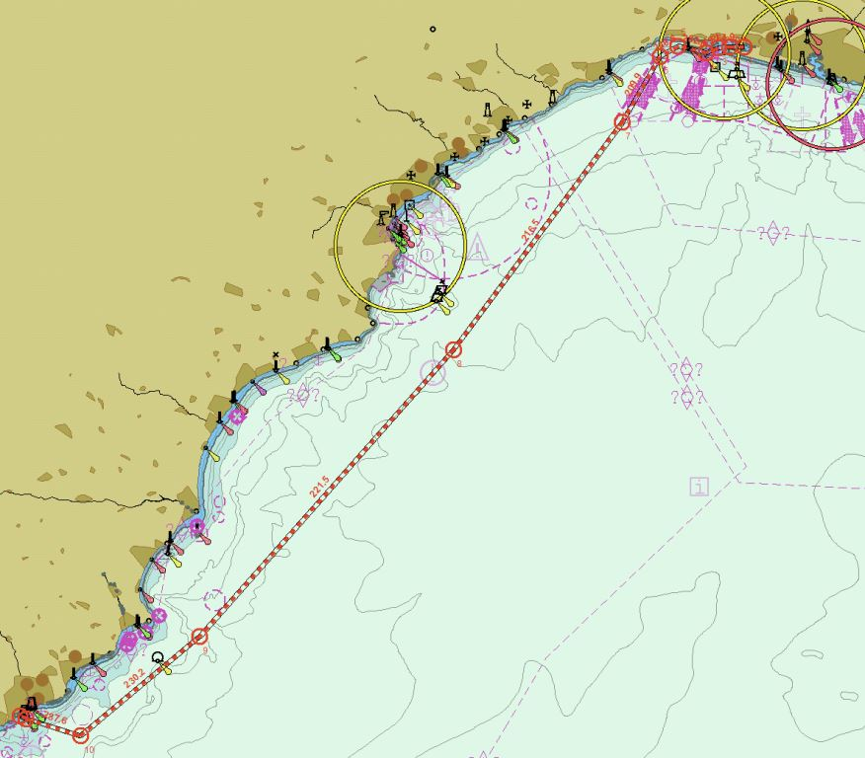

Publication to be checked:  o e-NP's (Sailing Directions and Admiralty Pilots)  o ALRS  o Annual Summary of Notice to Mariners  o Local Cruising Guides  o Routing Charts  o Nautical Almanac  o Local Port Regulations  o Ocean Passages of the World  o Admiralty Distance Tables  o Statistical Meteorology including currents and predicted forecast weather conditions  o Flag State mandated carriage requirements | Draft route to be planned on ECDIS with the following considerations:  o Great Circle or Rhumb Line  o Cross Track Distances (XTDs) relevant for each leg  o Traffic Separation Schemes  o Confined waters times of transit  o High risk areas (piracy or attack)  o Re-fuel locations  o Territorial Waters  o T's and P's relevant to track  o Time Zones  o Potential lack of GNSS  o CATZOC’s and poor ENC coverage  o Datums and chart source data  o Check shift values from WGS84  o Required ENC’s pre-licenced (if necessary)  o Appropriate safety settings (Safety Contour / Depth)  o Ice transit cautions (if relevant)

Are the following publications up to date?
All digital publications used must have relevant information attached to this pro-forma.
ADRS 1,3,4,5 |  | e-NP’s or hard copy Sailing Directions
ADRS 2 and 6 |  | Cruising Guides
Admiralty Total Tide |  | Other publications
ADLL |  | Back-up paper charts
ECDIS Charts Corrected up to Week:

RADIO CALLING POINTS
 | Station Call sign | VHF | Telephone | Notes
Departure Port
Departure Pilot
VTS Area
VTS Area
VTS Area
VTS Area
Arrival Pilot
Arrival Port

WAYPOINTS

See separate list extracted from ECDIS
NOTES:

TIDES – Port of Departure
Date: | HW: @ | LW: @
Range

TIDES – Point of interest on-route
Date: | HW: @ | LW: @
Range

TIDES – Port of Arrival
Date: | HW: @ | LW: @
Range

Following to be checked
Has the passage plan been checked for a minimum Under Keel Clearance?
Has the current weather been checked and forecast pages attached?
Are all waypoints printed and attached on following pages?
Have the following been completed on the ECDIS:
- Parallel Indexing
- Mariners Notes of importance (including radio calling points)
- Route scan and checked – hazards cleared or approved
- Appropriate settings on
- Approved by the Master and locked
Is ECDIS track overlayed onto RADAR?
Has the route been locked?
Has the watch schedule been created and posted?
Has the DPA been informed and updated crew and guest list forwarded to management?
Masters Comments:
Master: Signature:
OOW 1: Signature:
OOW 2: Signature:
Date:

VESSEL REPORTING INFORMATION
VESSEL NAME
VESSEL CALLSIGN
IMO NUMBER
MMSI
DRAFT
Local AGENT DETAIL
POSITION | N/S E/W
BEARING / DISTANCE FROM LANDMARK
COURSE
SPEED
LAST PORT OF CALL
NEXT PORT OF CALL AND ETA
TOTAL PERSONS ON BOARD
NO. OF CREW
NO. OF PASSENGERS
NAVIGATIONAL CONDITION/FAULTS
BUNKERS ON BOARD
LUBE OIL

